Title: Introduction to EEG and Brain-Computer Interface

Course: ECBM 4090

09.12/2024

Ian Huang, Lindsey Ma, Giuliana Cascarano

[Nima Mesgarani](mailto:nima@ee.columbia.edu)

**1. Introduction**

EEG 10-20 electrode system is a way to place and identify electrodes on the scap. Usually they are separated by 10% or 20% from a known location on the head. Electrodes are identified through the lobe (which are usually labeled by letters of the lobe) or the relative position to the midline (which are usually labeled by numbers).

Our objective of the experiment is to try to get data from our EEG and observe the different artifacts listed below.

**2. Experiment 1: Capping the Subject**

Question 1: What is the distance between the nasion and the inion (DNI)?

Answer: 42 cm

Question 2: What is 50% of the DNI?

Answer: 21 cm

Question 3: What is the ear-to-ear distance?

Answer: 45 cm

Question 4: What is 50% of the ear-to-ear distance?

Answer: 22.5 cm

**3. Experiment 2: Building the Biosignal Recording System and Testing with Simulink**

Question 1: Were you able to successfully set up the equipment? Any issues?

Answer: First, we capped the cap on the subject and made sure the measurements of the electrodes were correct. We also put the “ground” in front of the head, and made sure we had a reference behind the ear. We connected EEG with g.USBamp and plugged it into the PC. We also turned on MATLAB Simulink and the signal started coming in. Overall, we are able to get our equipment running and get signals from the scalp.

Question 2: Did the sine wave test work correctly?

Answer: Yes.

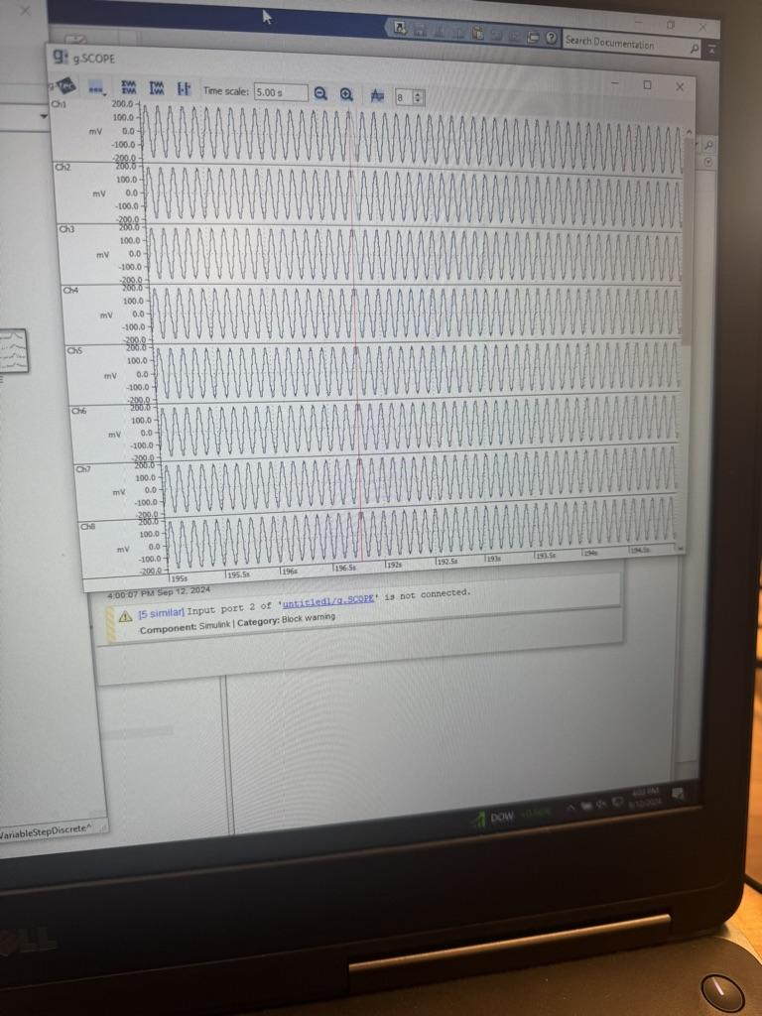

**4. Recording EEG Data**

Question 1: Describe the signal before applying gel and during the following conditions:

Observations for each condition, including changes in signal amplitude, frequency, or noise are included below:

i. Blinking eyes:

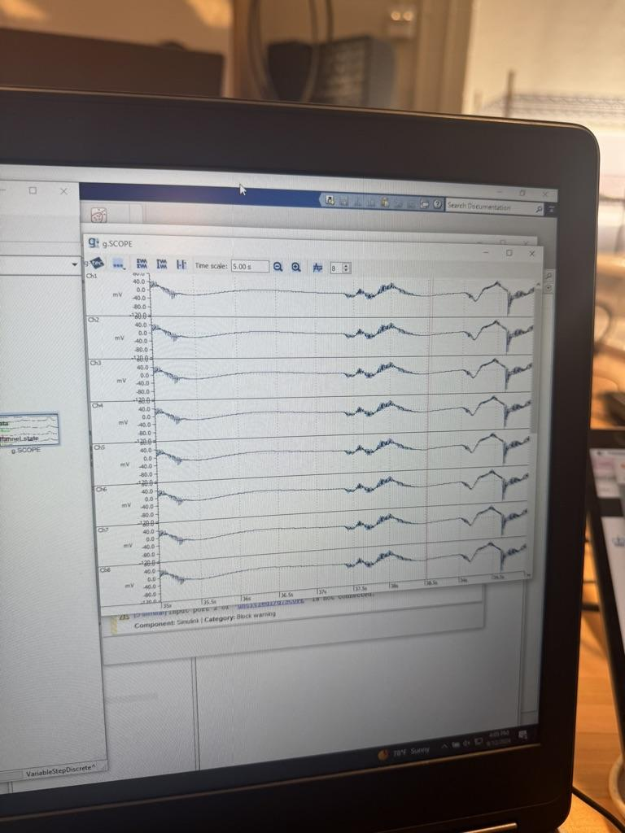

We observed a big change in the signal whenever the blinking occured. The changes in voltage from the blinking were much more evident after normalizing the data.

ii. Rolling eyes:

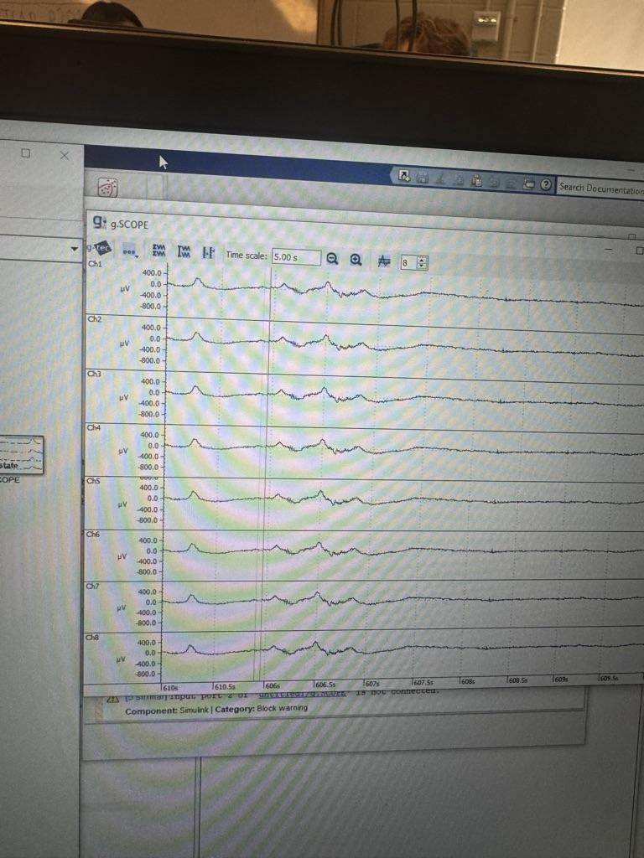

It was hard to identify differences when normalized but there were small differences which aligned to the rate at which our test subjects' eyes were being rolled.

iii. Tensing neck muscles:

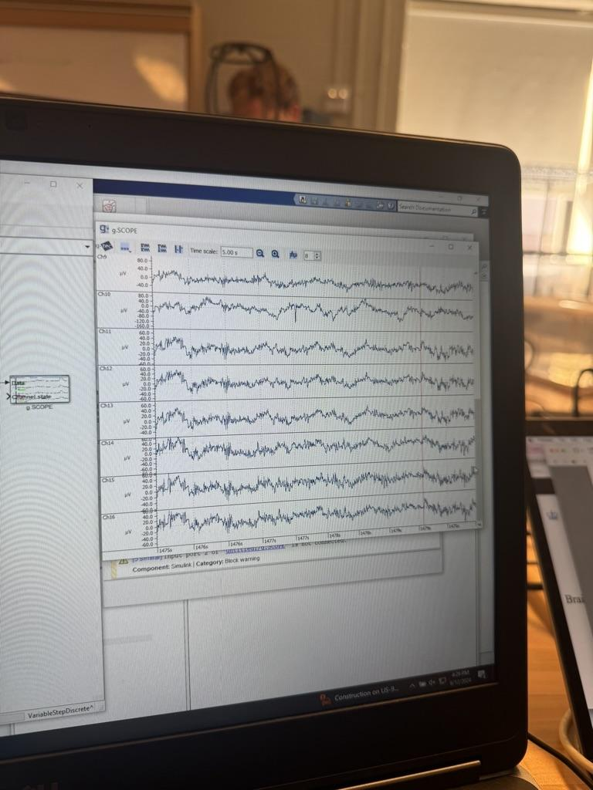

Tensing neck muscles provided stronger changes in frequency but it seemed to also result in greater noise as it was hard to see an observable pattern. This noise may be caused by strong muscle electrical activity, overlapping with the EEG signals we intended to capture.

iv. Clenching jaw:



Jaw clenching seemed to be the strongest electric signal that was picked up but again had a lot of noise and it was difficult to identify the patterns. Channel 11-16 behaved similarly since they all located in the occipital region.

v. Closing eyes:

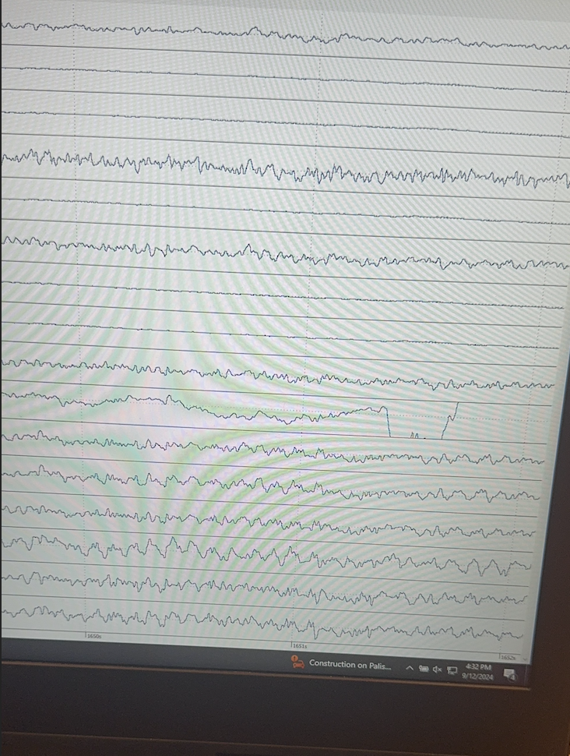

No visible patterns in the signal when eyes are closed.

Question 2: Describe the signal after applying the gel and during the same conditions:

The signal quality significantly improved and we were able to successfully identify patterns associated with movement from the signal.

i. Blinking eyes:

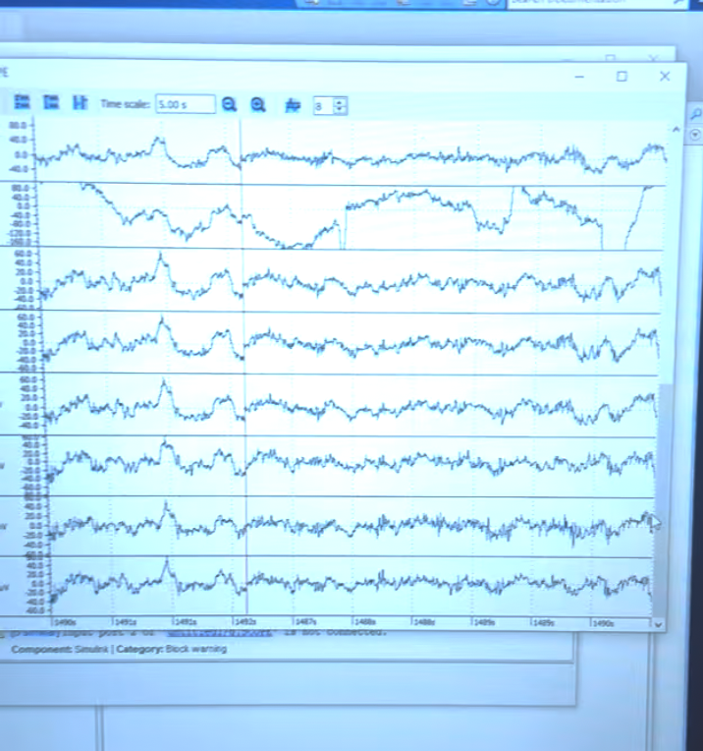

The blinks produced a characteristic spike in the signal. Despite the improvement in signal quality with gel, there was still some noise across multiple channels, though most were relatively consistent. An anomaly was detected in channel 2 (FC2), possibly due to insufficient gel application. The pattern is not really similar with the pattern without gel though.

ii. Rolling eyes:

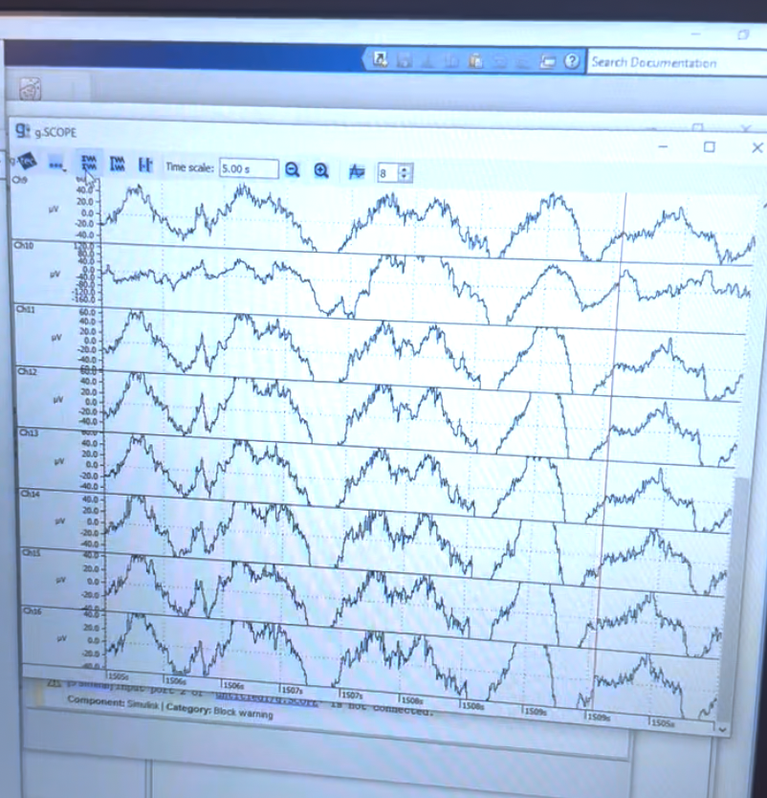

With eye rolling there were stronger waves present and we see a greater wavelength than with the blinking. This pattern was much more consistent and strong with the timing of the eye rolling when the gel was applied.

iii. Tensing neck muscles:

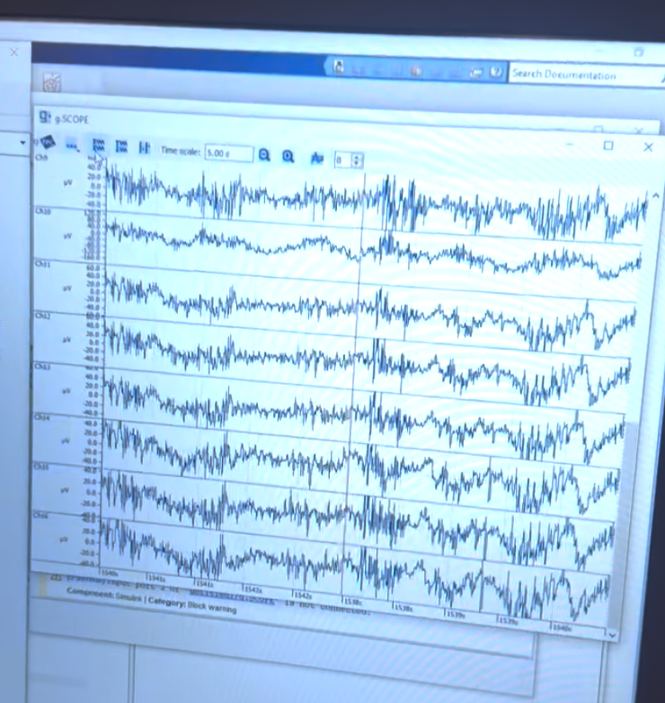

Tensing neck muscles had a great impact on the data and the action was visible as many concentrated spikes instead of prolonged waves. The pattern is similar with and stronger than that without gel.

iv. Clenching jaw:

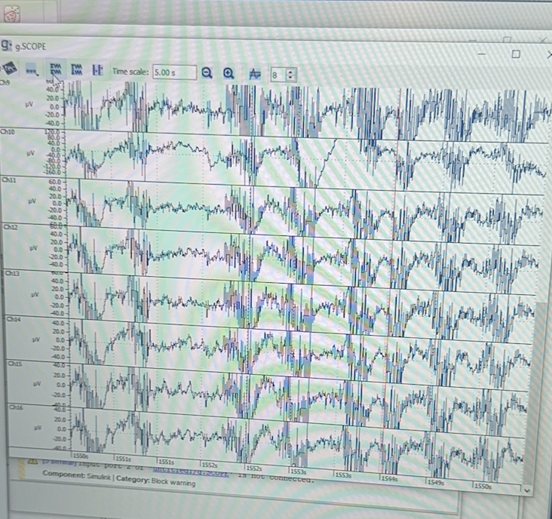

Jaw clenches have really strong repeated spikes of a short wavelength. We can see the clenching and release pattern much more clearly with the gel. As we can see the pattern from this outcome, we suppose that the noise is less than that without gel.

v. Closing eyes:

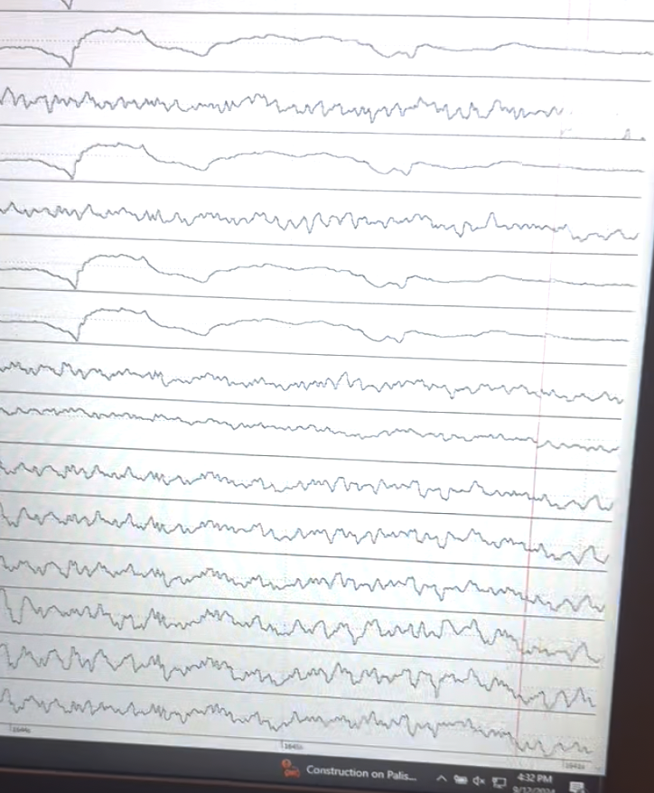

We observe strong indications of synchronized alpha waves. But different channels behave differently and seem not really related to their region.

Answer: There are significant improvements in the signal quality after applying the gel. It is much more evident that the voltage is changing in synchrony with the movements of the participant.

Question 3: Can you observe the same effects after removing the notch filter?

i) Blinking:

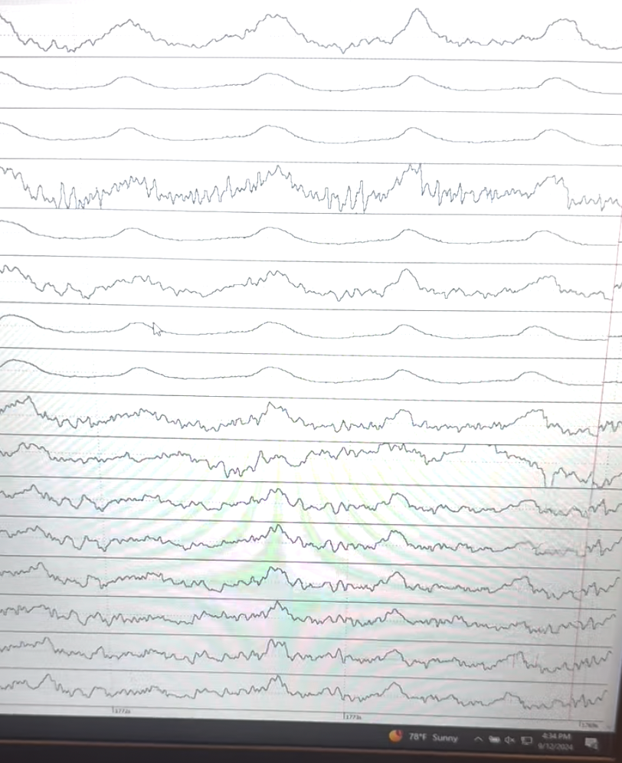

After removing the filter, there is a clear pattern of blinking. Channels 2-5 and 7-8 show similar results (though channel 4 is not functioning well), displaying smooth alpha waves with moderate fluctuations and minimal noise. Channels 1 and 6, which reflect signals from the midline of the brain, show higher power levels compared to channels 2-5 and 7-8 but are similarly smooth. Channels 9-10 did not perform significantly, as they showed oscillations. Channels 11-16 presented peaks during blinking, along with some small fluctuations.

ii) Rolling eyes

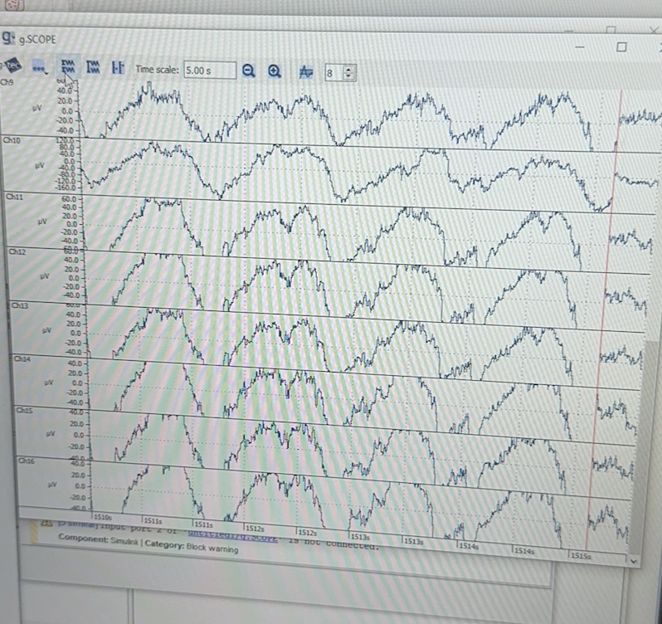

There are significant and strong patterns, similar to the previous two, regardless of the filter applied. Each time the subject rolled her eyes, a gradual voltage change occurred, followed by a return to baseline after the movement ended.

iii) Tensing neck muscles

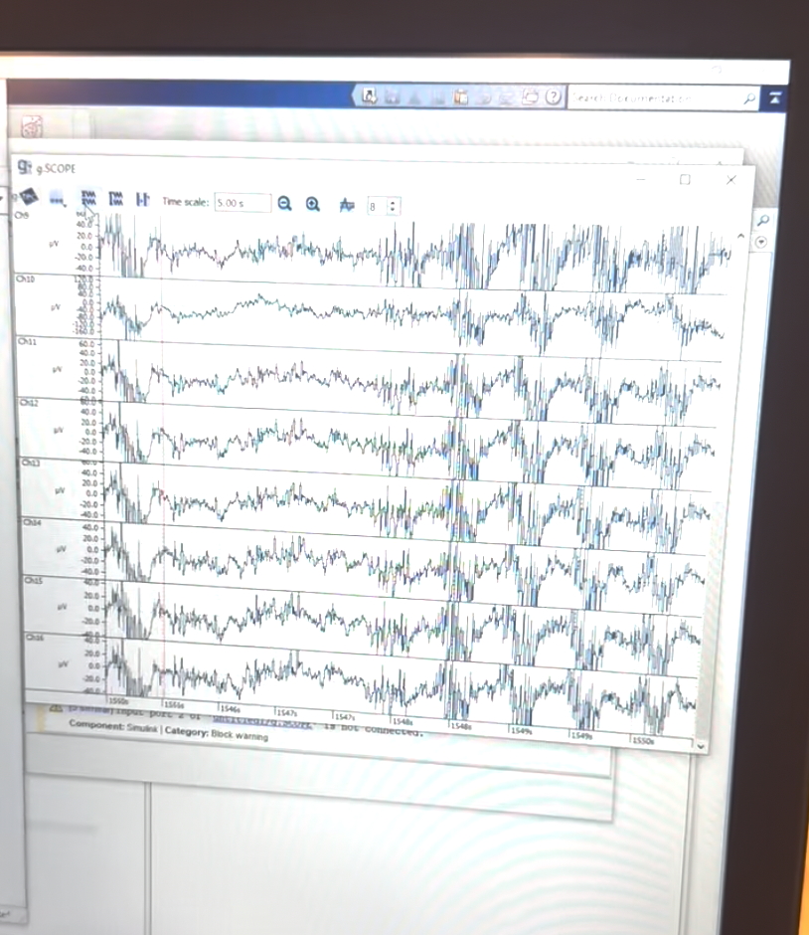

There are still strong fluctuations compared to other movements, but this time we have a clearer pattern indicating the start and end of each movement. We believe this is because, after removing the filter, we captured more muscle activity from other frequency bands.

v) Clenching jaw

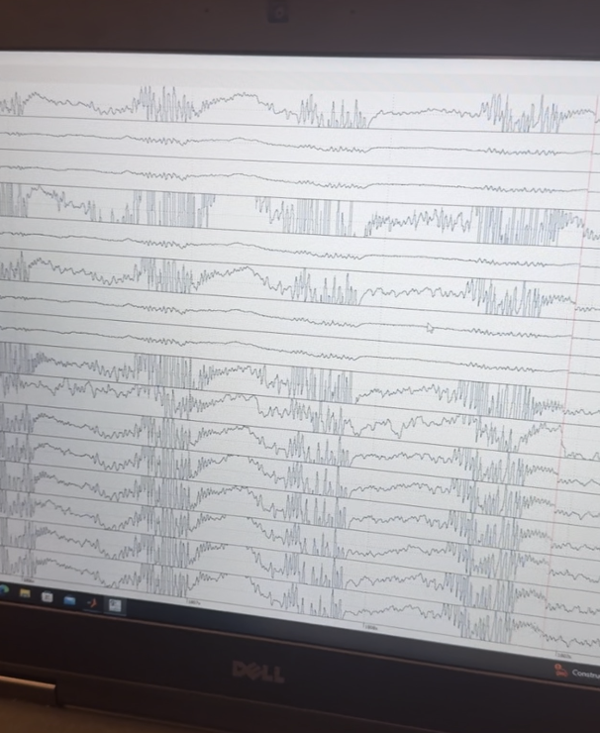

vi) Closing eyes

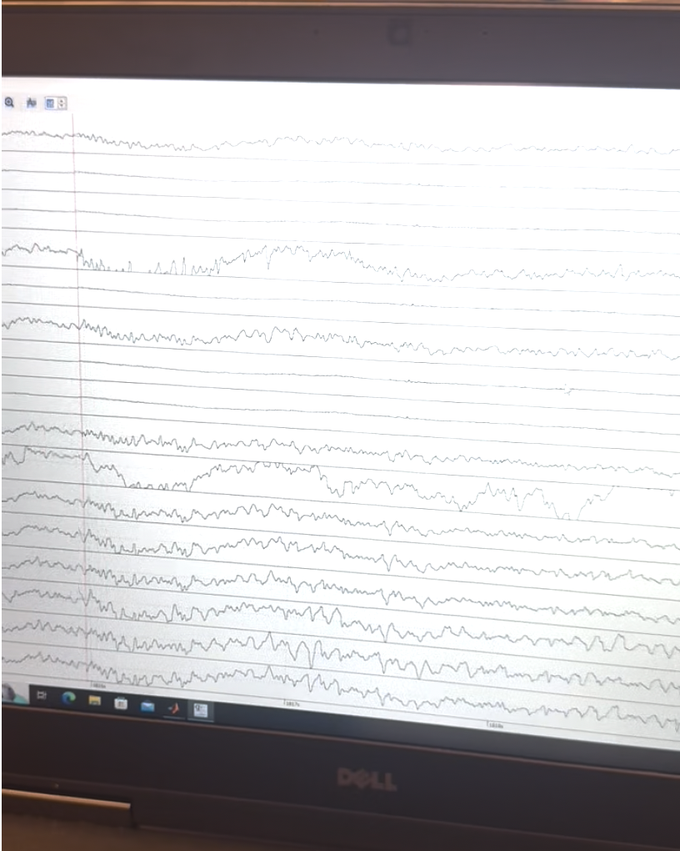

Answer: We observed that more frequencies were shown, meaning that there are some slow drifts observed from artifacts and high frequency noise such as electrical noise observed after removing the notch filter and bandpass.

**5. Troubleshooting**

Question 1: Were there any issues with the equipment, gel application, or signal quality? How did you troubleshoot?

Answer: The biggest learning curve we had was how to apply the gel. We realized that it’s important to make sure the gel is reaching the scalp. Otherwise we did not have to troubleshoot anything because the signal was much clearer once we put the gel on.

Besides, we found out that some signals did not work as we expected, maybe not the pattern we wanted or not similar among channels. We think we need to reduce noise and take video instead of photos of signals to analyze them better. Some recording or analyzing software may help as well.